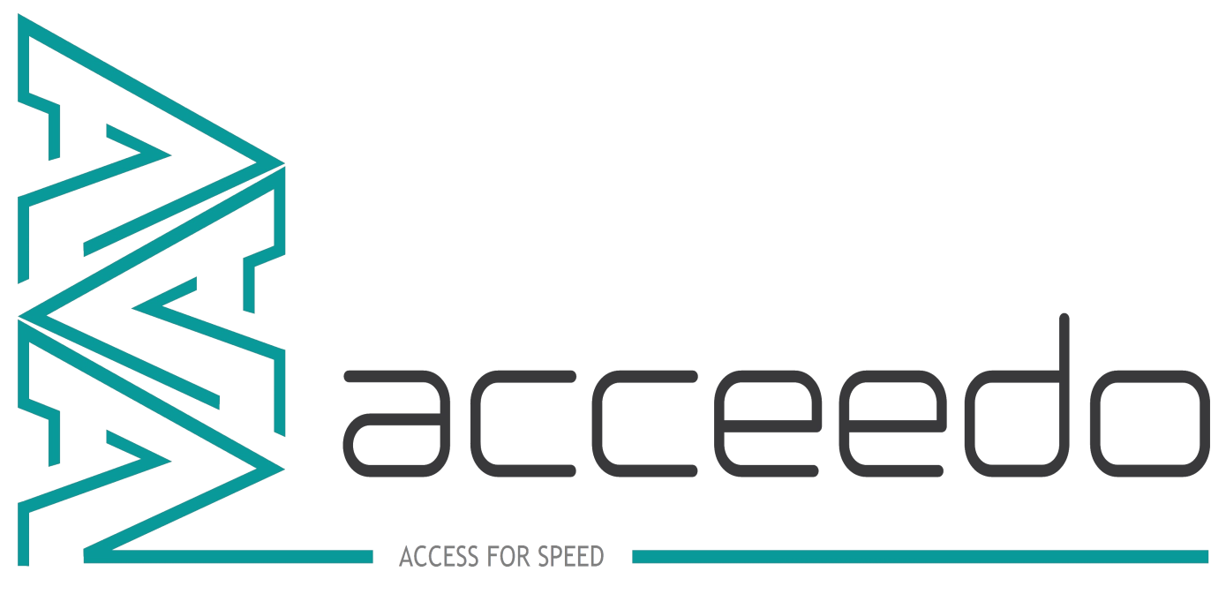

**ACCEEDO LIMITED**

**INDUSTRY 4.0**

**Taking You Forward**

# Heat treatment Device

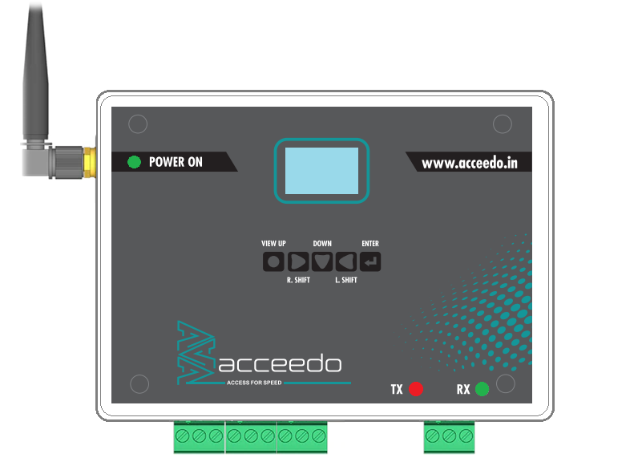

# Heat treatment Web Application.

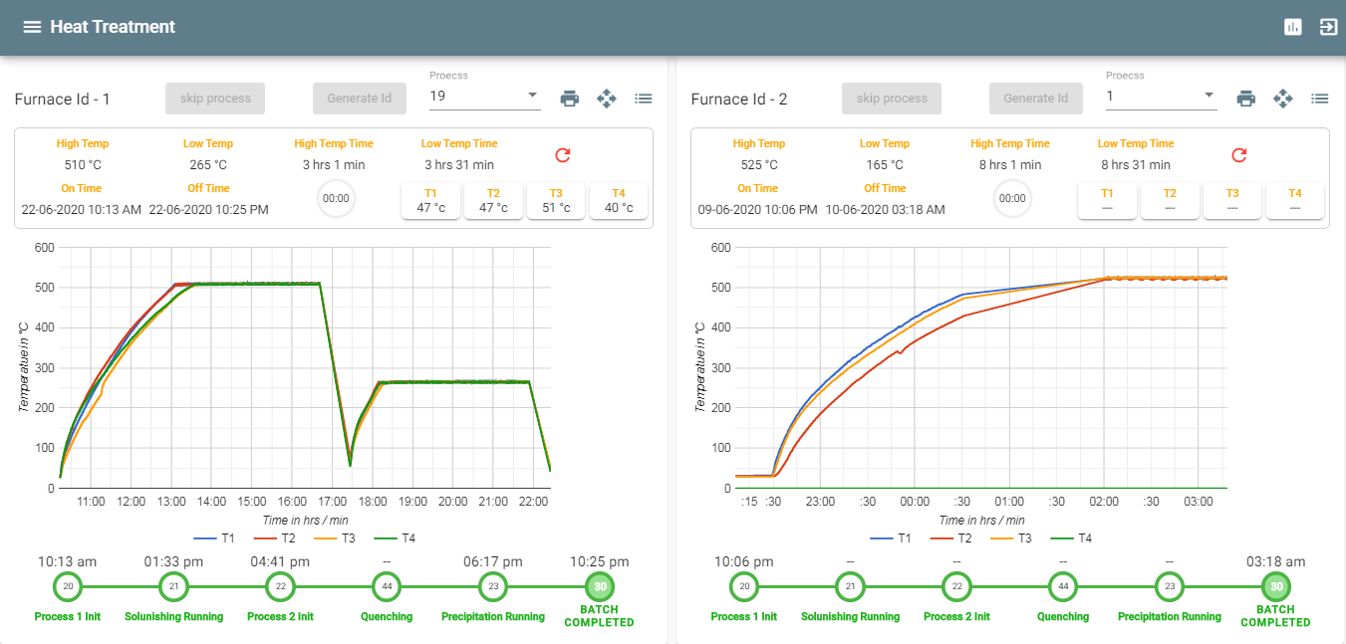

ABOUT ACCEEDO

Acceedo provides the solutions for IoT specialized in various foundries, when applied to the manufacturing industry, the concept of integrating smart manufacturing machinery, automation, and advanced analytics to help make every worker and every factory more efficient. The main aim is to create smarter, more efficient manufacturing through the use of IoT. This will be achieved by various technologies communicating in a way that allows autonomous running of the facility and processes.

Our Mission

We are deploying IoT devices and machinery that are connected by communication technologies that assist industries in collecting data, monitoring machine health, analyzing employee performance, and delivering data to management; our goal is always the same; to improve operational efficiency through analytics, automation and connectivity.

Our Vision

We are improving the manufacturing industry by giving manufacturers, more visibility throughout the manufacturing process and by making data immediately available to multiple data consumers and applications.

Why us

By utilizing machine learning, systems can be trained to identify potential patterns that could result in a future failure; and if the results are concerning, then it can be automatically reported for further investigation. Such applications can help save companies millions, or even billions of rupees.

Who We Are

Acceedo is a one-stop solution provider for embedded product, software engineering and development. We are improving the manufacturing industry by giving manufacturers, more visibility throughout the manufacturing process and by making data immediately available to multiple data consumers and applications.

**Online Heat treatment Monitoring System**

# Why Online Heat Treatment Monitor?

1. Spend a little over a conventional plotte
2. Any number of heat cycles/ curvers can be recorded
3. View live data of your HT process on your PC/Mobile
4. Cycle time can be pre-set for each individual item.
5. It’s that easy---> Choose item name on your mobile and start cycle
6. Monitors Energy for every cycle (* A network compatible energy meter required).
7. Send HT cycle reports to your customer for any of the batches.
8. Save energy by monitoring and comparing each cycle.
9. Option to store data on cloud if hardware not available at premises.
10. Additional reports can be added and customized to specific need at a cost.
11. E-mail of individual HT cycles is also possible.

# Who should install online Heat Treatment Monitor?

1. A factory needing to digitize and move towards upgrading and Industry 4.0
2. Better control on the process.
3. Improve Energy utilization.
4. Ease of maintaining logs and reports.

# Why AMC?

1. To provide with software upgrades over time.
2. To check and calibrate hardware.
3. Monitor the effective usage and efficiency of the system.

**Online Heat treatment Monitoring System Models & cost**

|  |  |
| --- | --- |
| **Model 1 - Device + Software** | |
|
| **S.No** | **Modules** |
| 1 | Heat treatment Module (Device). |
| 2 | System Software. |
| 3 | Android Application. |
| **Cost Per furnace : 50,000/-** | |
| **BFC Marketing Commission :** | |
| **\*Condition**: *Cost of controller not included. Either has to be provided by customer* | |

|  |  |
| --- | --- |
| **Model 2 - Device + Software+ Temperature Controller** | |
|
| **S.No** | **Modules** |
| 1 | Heat treatment Module (Device) |
| 2 | System Software |
| 3 | Android Application |
| 4 | Per Temperature Controller * |
| **Cost Per furnace : 50,000/-**  **Cost Per Controller : 6,000/-** | |
| **BFC Marketing Commission :** | |
| **\*Condition**: *Cost May be vary depends on controller Manufactures and Models.* | |

|  |  |
| --- | --- |
| **Model 3 - Monthly Subscription (12 Month Duration)** | |
|
| **S.No** | **Modules** |
| 1 | Heat treatment Module (Device) |
| 2 | System Software |
| 3 | Android Application |
| **Monthly Cost Per furnace : 5000/-** | |
| **BFC Marketing Commission :** | |
| * **Condition**: *Cost of controller not included. Either has to be provided by customer* | |

*TERMS AND CONDITIONS:*

|  |  |
| --- | --- |
| *Warranty* | *1 Year Warranty* |
| *Payment Methods* | *One time.*  *(or)*  *Monthly Subscription.(12 Duration)*  *Subscription Method:*   1. *Cost to be paid on a monthly basis.* 2. *Additional hardware cost for temperature controller will have to pay upfront if required at premisis.* 3. *Software will be installed at customer’s premisis only after subscription period is complete.* |
| *Annual Maintenance Contract (AMC)* | *Yearly AMC Charges Rs-5000/-*  *No of Visit per year 4 times* |
| * *Customize report cost applicable additionally Rs.5000/-* * *Wi-Fi modem has to be provided by customer* | |
|  | |

***Office Address:***

###### Acceedo

###### Plot No: 9A,

###### Private industrial Estate,

###### Sidco, Kurichi, Cbe - 641021.

###### **Email**: [info@acceedo.in](mailto:info@acceedo.in)

***Web:*** [www.acceedo.in](http://www.acceedo.in)

Phone: +91-422-4511400.